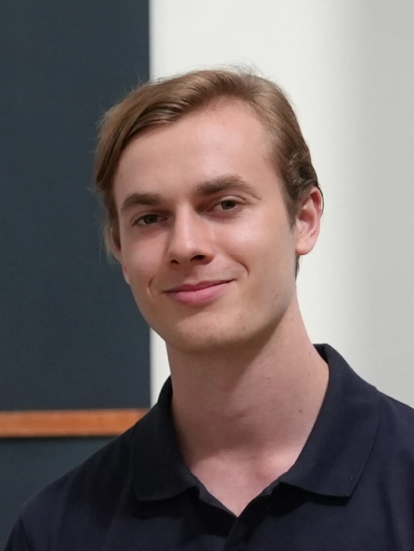 Sander Schulhoff is the Founder of Learn Prompting & HackAPrompt. In October 2022, he published the 1st Prompt Engineering Guide on the Internet—two months before ChatGPT was released. Since then, his courses have trained over 3 million people, and he is one of two people (other than Andrew Ng) to partner with OpenAI on a ChatGPT course. He has led Prompt Engineering workshops at OpenAI, Microsoft, Stanford, Deloitte, and Dropbox.

He is an award-winning Generative AI researcher from the University of Maryland and the youngest recipient of the Best Paper Award at EMNLP 2023, the leading NLP Conference, selected out of 20,000 submitted research papers. His research paper on HackAPrompt, Ignore This Title and HackAPrompt, has been cited by OpenAI in three major research papers: Instruction Hierarchy, Automated Red Teaming, and Adversarial Robustness.

He created HackAPrompt, the first and largest Generative AI Red Teaming competition. Most recently, he led a team from OpenAI, Microsoft, Google, and Stanford on The Prompt Report—the most comprehensive study on Prompt Engineering to date. This 76-page survey analyzed over 1,500 academic papers, evaluating the effectiveness of prompting techniques, AI agents, and Generative AI applications.