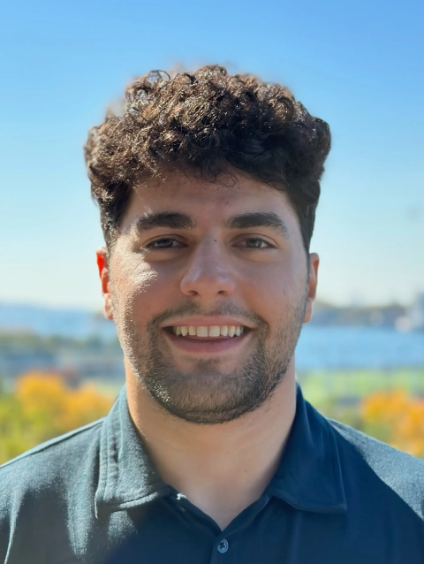 Fady Yanni is a three-time founder and the COO of Learn Prompting, an enterprise-grade eLearning platform for Generative AI, AI Red Teaming, and Prompt Engineering. Learn Prompting's mission is to upskill and reskill the world on essential AI skills! To date, they've taught over 3 million people how to use AI, partnered with OpenAI to release a course on ChatGPT, and have been featured in Forbes, Bloomberg, Wired, etc.

Previously, he was the Head of Fundraising for the Farama Foundation, a non-profit that maintains nearly every major open-source Reinforcement Learning library, including OpenAI's flagship project, Gym.